**Measuring the weather at Rothamsted**

**Temperature**

Draw an arrow to the hottest day last year (blue line). What was the temperature ? _______0C

Draw an arrow to the coldest day last year (blue line). What was the temperature ?_______0C

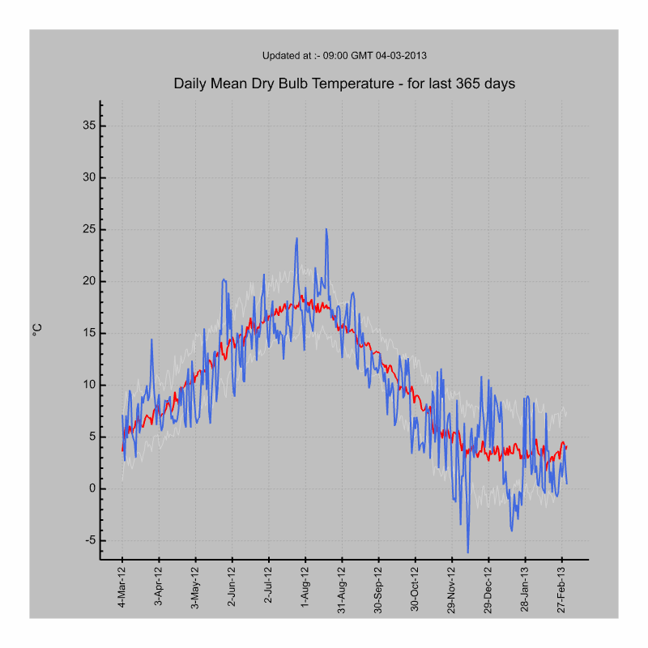

[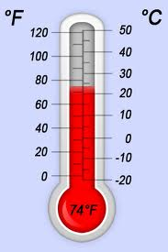](http://www.google.co.uk/imgres?q=thermometer&um=1&hl=en&biw=1187&bih=778&tbm=isch&tbnid=Am3o0jKTirBTnM:&imgrefurl=https://itunes.apple.com/gb/app/thermometer-free/id380880310?mt=8&docid=MFdjnlTx8En2cM&imgurl=http://a72.phobos.apple.com/us/r1000/059/Purple/1a/e6/39/mzl.vwijkkca.320x480-75.jpg&w=320&h=480&ei=dn00UaTUBqO60QW-noGgDw&zoom=1&iact=hc&vpx=474&vpy=218&dur=1529&hovh=275&hovw=183&tx=92&ty=134&sig=115730347514383301681&page=1&tbnh=148&tbnw=99&start=0&ndsp=32&ved=1t:429,r:28,s:0,i:232)

Thermometer

Red line = average temperature of all years

Blue line = the temperature of the 365 days (ie a year)

**Rainfall**

Draw an arrow to the wettest day last year.  
Roughly how much rain fell on the wettest day? _______ mm

[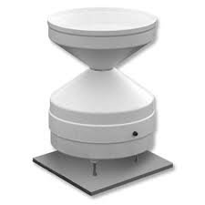](http://www.google.co.uk/imgres?q=rain+gauge&start=239&um=1&hl=en&biw=1187&bih=778&tbm=isch&tbnid=PQO9u0SZjyZKBM:&imgrefurl=http://www.waterra-in-situ.com/pages/product/Raingauges.asp&docid=_tIFdXux0TNQJM&imgurl=http://www.waterra-in-situ.com/images/product/RainGauge_pro.jpg&w=300&h=300&ei=JH40UbCcO82W0QW9j4HYBg&zoom=1&iact=hc&vpx=847&vpy=346&dur=328&hovh=225&hovw=225&tx=110&ty=109&sig=115730347514383301681&page=7&tbnh=137&tbnw=136&ndsp=40&ved=1t:429,r:45,s:200,i:139)

Rain gauge

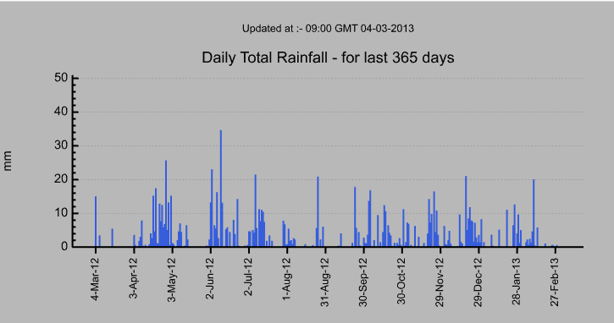

**Sunshine**

What part of the year has most sunshine (the red line)? **Summer** or **Winter** – circle your answer  
Draw an arrow to the sunniest day.

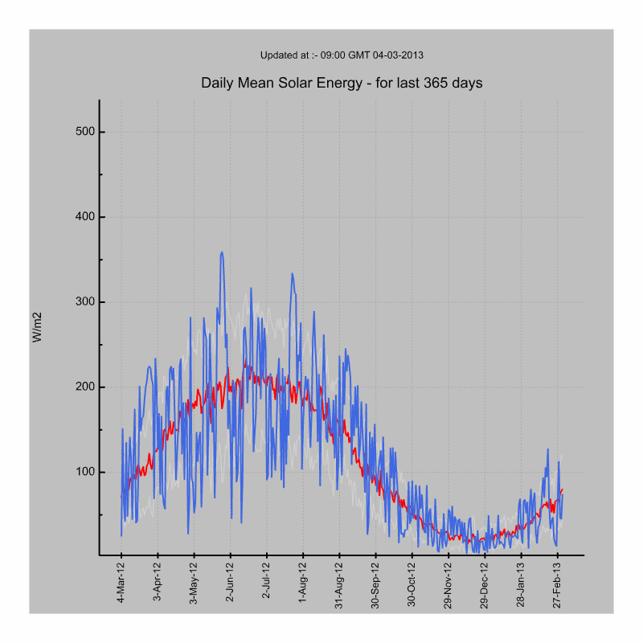

Red line = average of all years

Blue line = the sunshine over the last year

Winter

Summer

**[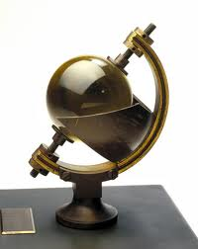](http://www.google.co.uk/imgres?q=measuring+sunshine&um=1&hl=en&biw=1187&bih=778&tbm=isch&tbnid=xiVVoYl0wJ7bbM:&imgrefurl=http://sciencemuseumdiscovery.com/blogs/collections/measuring-sunshine/&docid=nv9BrKEOMG1PMM&imgurl=http://www.ssplprints.com/lowres/43/main/15/94381.jpg&w=341&h=428&ei=p340Ub-ZLebB0QXp6YH4BA&zoom=1&iact=hc&vpx=145&vpy=96&dur=5553&hovh=252&hovw=200&tx=122&ty=123&sig=115730347514383301681&page=1&tbnh=140&tbnw=111&start=0&ndsp=27&ved=1t:429,r:1,s:0,i:80)**

**Sunshine recorder**

**Wind**

Which direction is most wind coming from? **South West (SW)** or **North West (NW)**  (circle your answer)

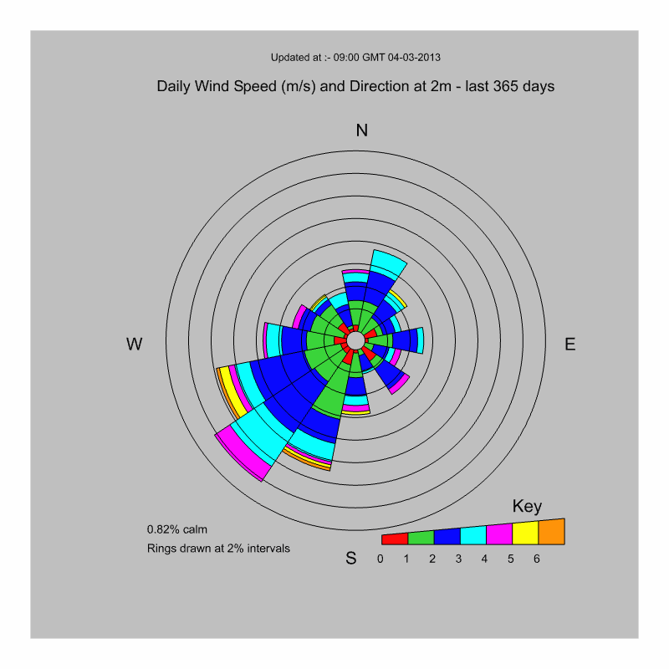

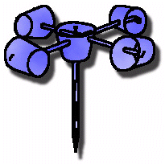

Anemometer